1. Find context-free grammars for the following languages

- L = {a^{n}b^{m}: n = m -1}
s: s1;
s1: a s1? b s1? | b s1? a s1? | b;
- L = {a^{n}b^{m}: n = m +3}
s: s1;
s1: a s1? b s1? | b s1? a s1? | a s2 | s2 a;
s2: a s2? b s2? | b s2? a s2? | a s3 | s3 a;
s3: a s3? b s3? | b s3? a s3? | a;

2. Show that the following grammars is ambigous

S → AB | aaB
A → a | aA
B → b

Input aab is ambigous in this language
=> 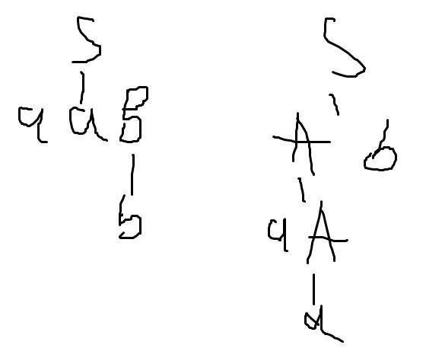

S → aSbS|bSaS|λ
Input abba is ambigous in this language

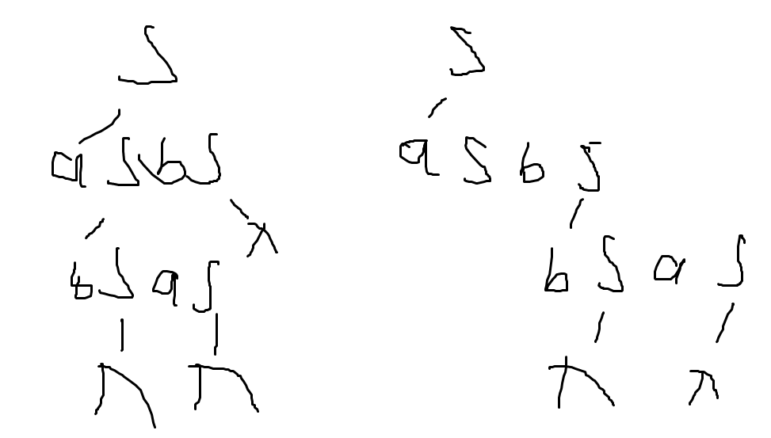

3. Draw the parse tree and evaluate the results of the following expression with the given grammars.

2
3-2
3*2
3+2*2
(3+2)*2
7-2-1
7-(2-1)

G1:

E → E+T | E – T | T
T→ T*F | T/F | F
F → (E) | Int

G2:

E → E*T | E / T | T
T→ T+F | T- F | F
F → (E) | Int

G3:

E → E – T | T
T→ T+F | T*F | T/F | F
F → (E) | Int

G4:

E → T+E | T – E | T
T→ F*T | F/T | F
F → (E) | Int

G5:

E → E – T | T
T→ F+T | F*T | F/T | F
F → (E) | Int

 | G1 | G2 | G3 | G4 | G5
2 | 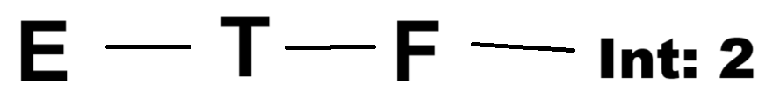  Result: 2
3-2 | 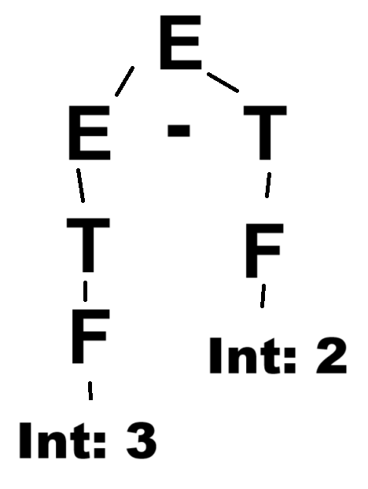  Result: 1 | 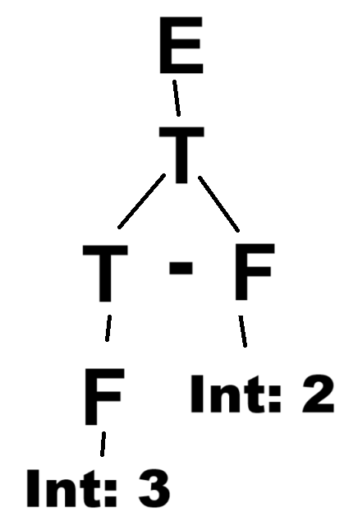  Result: 1 | Result: 1 | 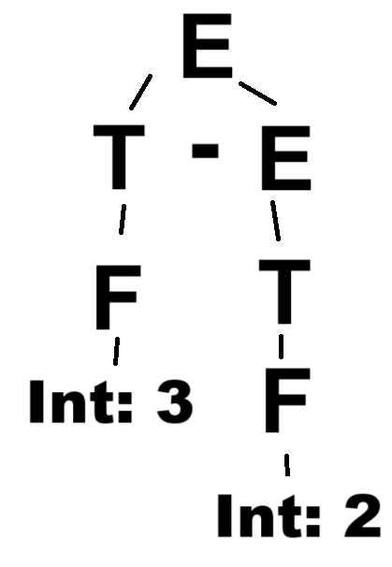  Result: 1 | Result: 1
3*2 | 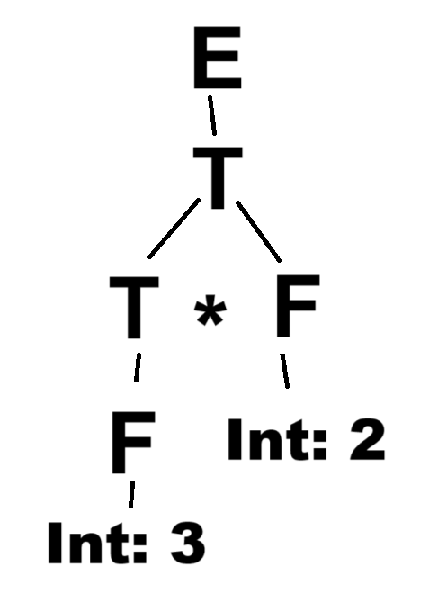  Result: 6 | 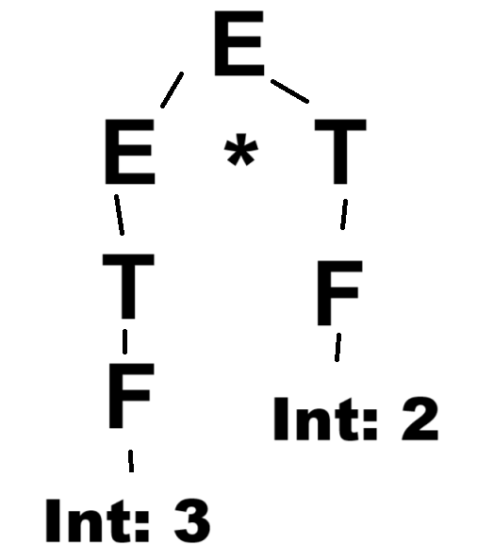  Result: 6 | Result: 6 | 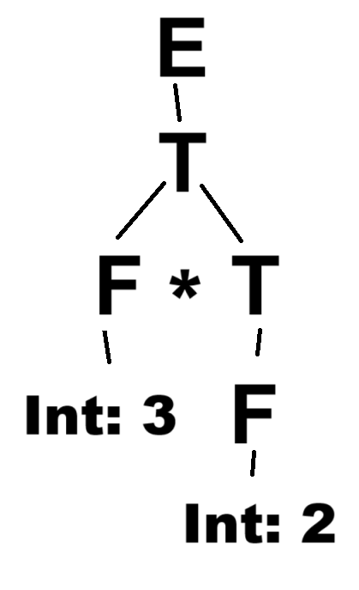  Result: 6 | Result: 6
3+2*2 | 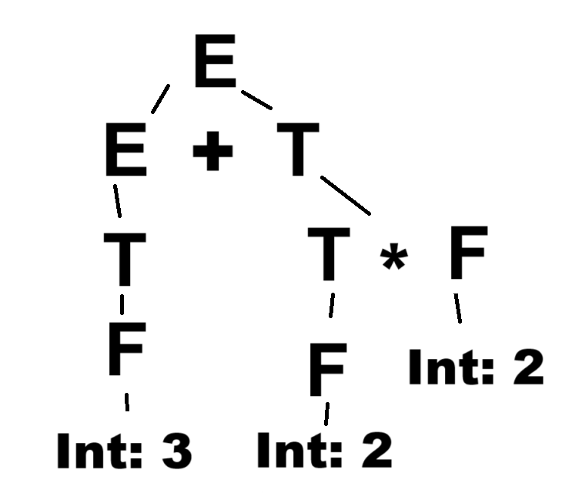  Result: 7 | 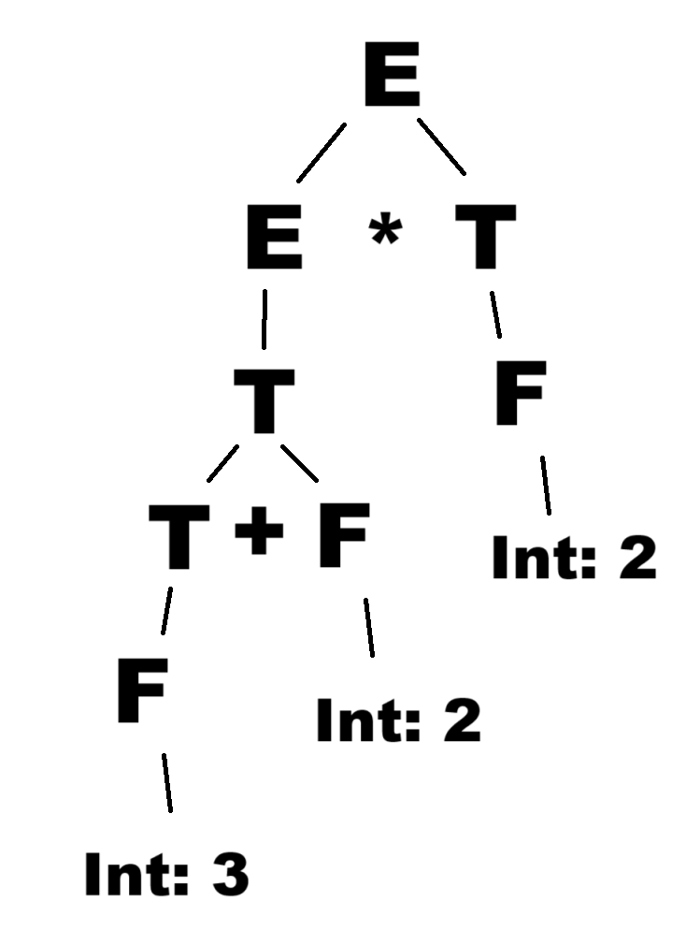  Result: 10 | 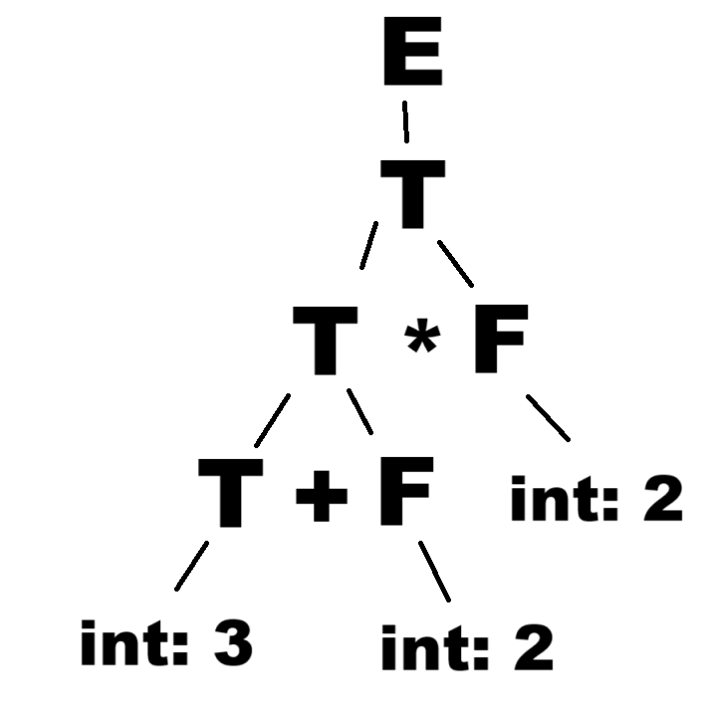  Result: 10 | 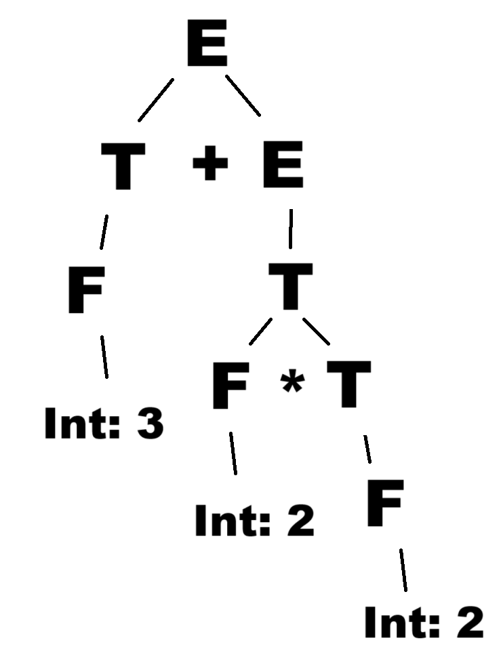  Result: 7 | 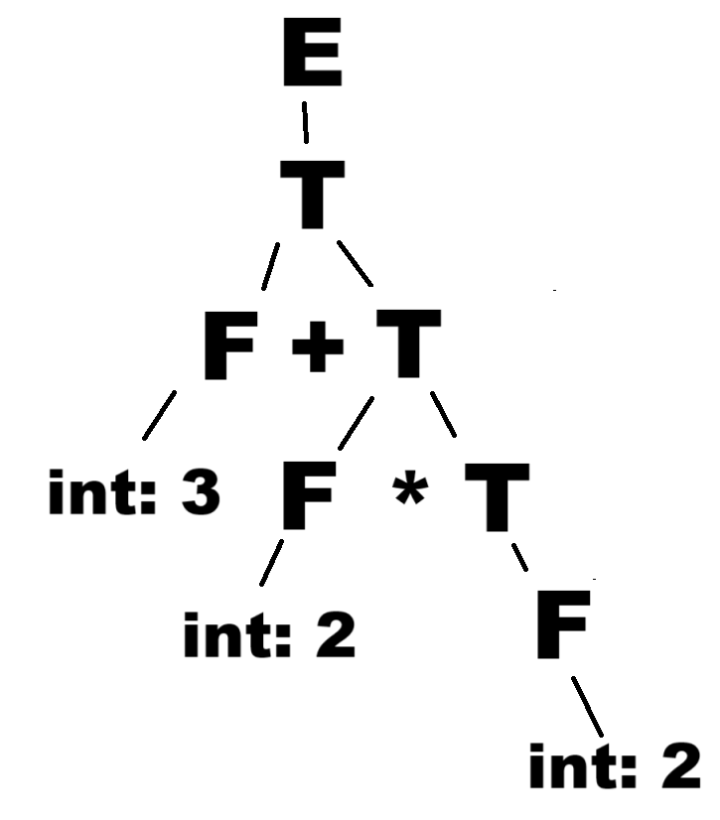  Result: 7
(3+2)*2 | 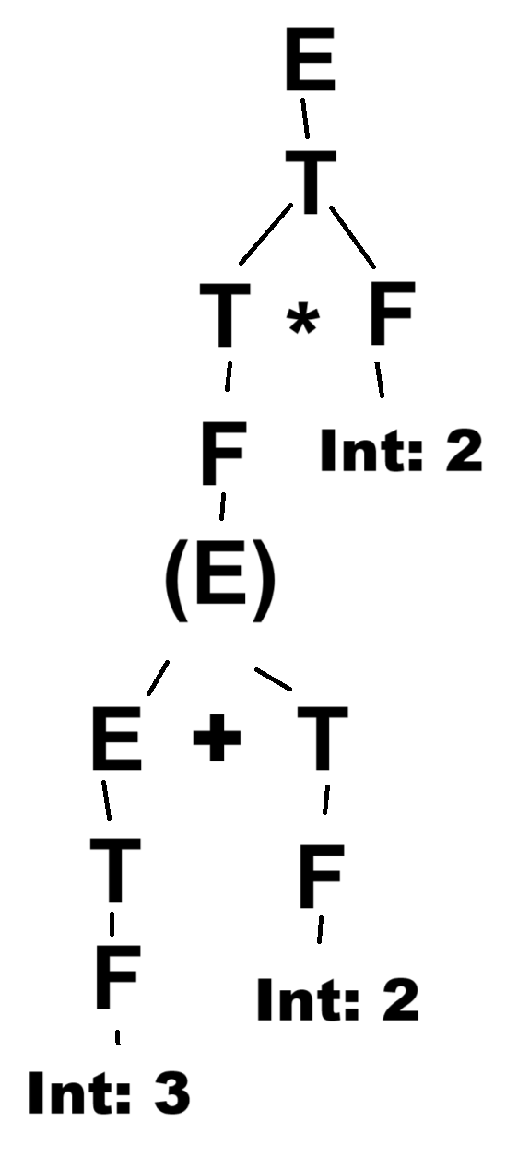  Result: 10 | 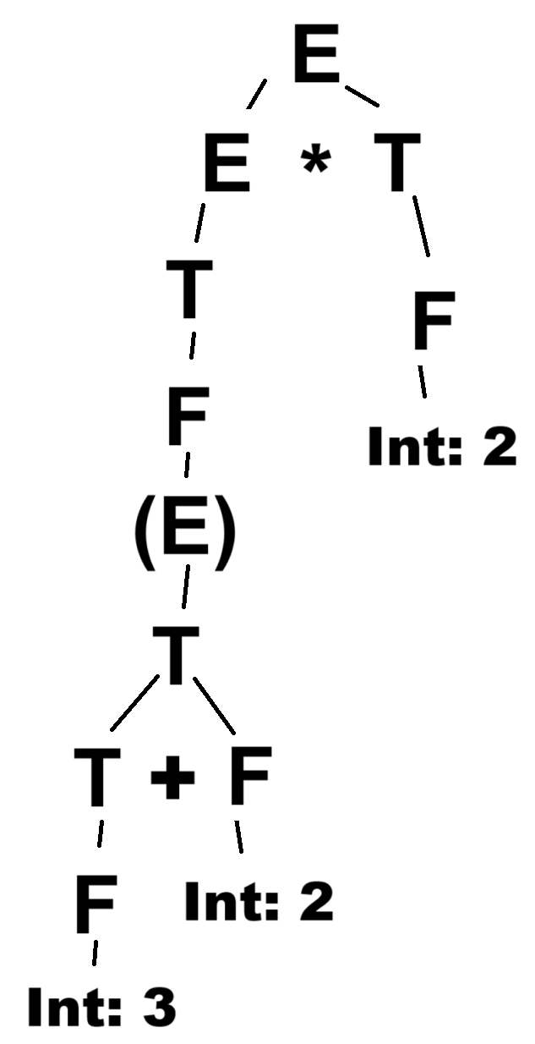  Result: 10 | 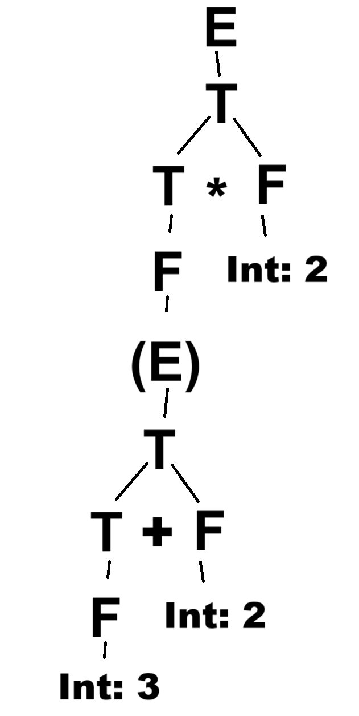  Result: 10 | 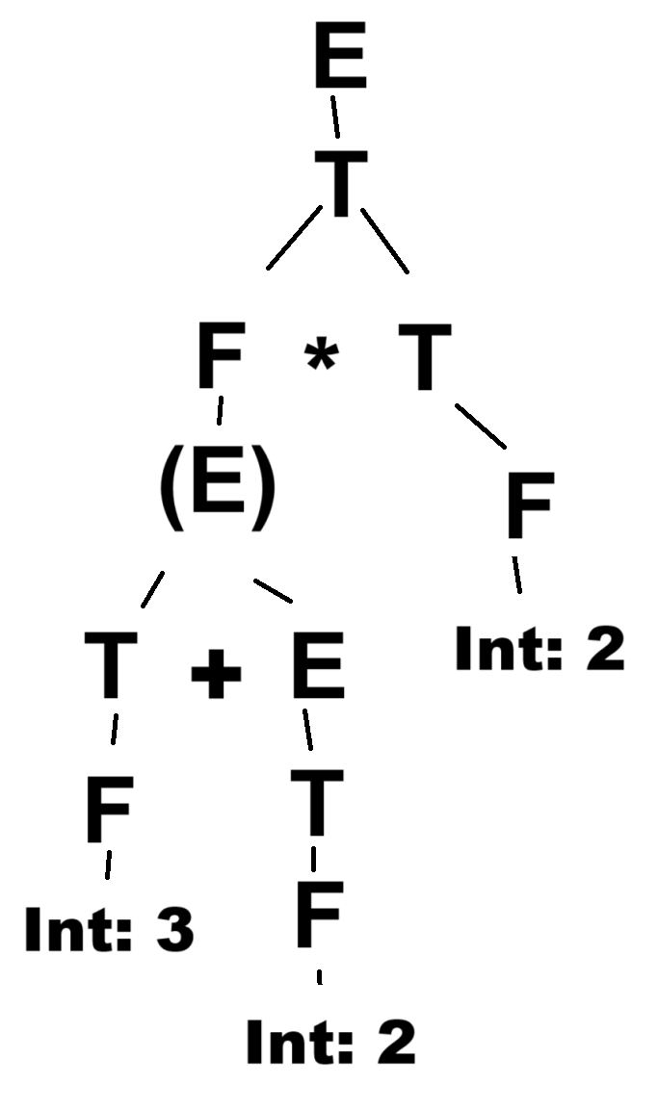  Result: 10 | 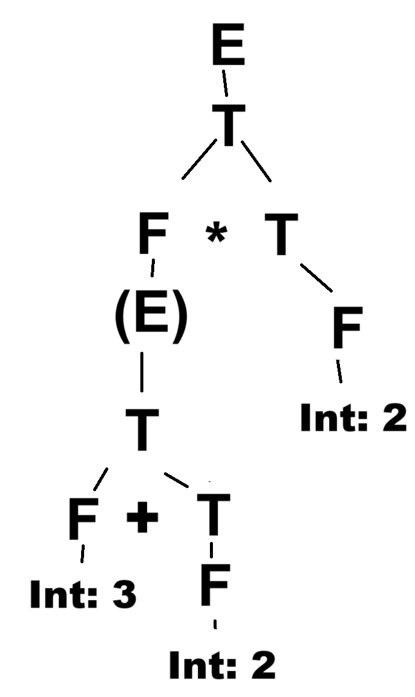  Result: 10
7-2-1 | 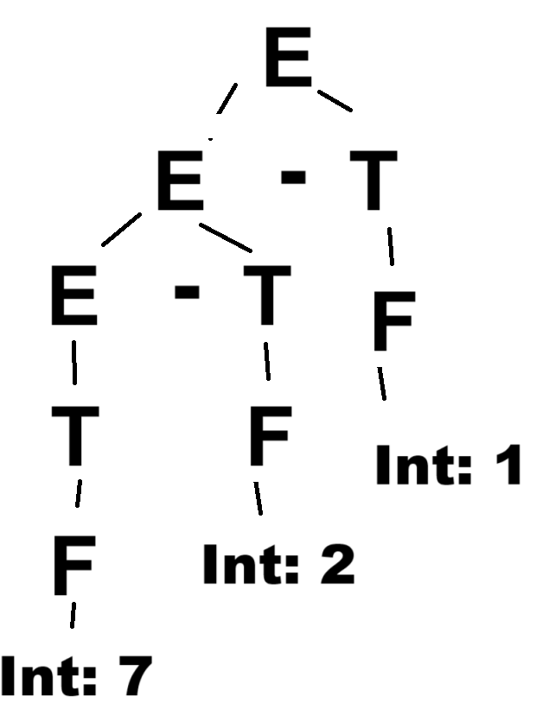  Result: 4 | 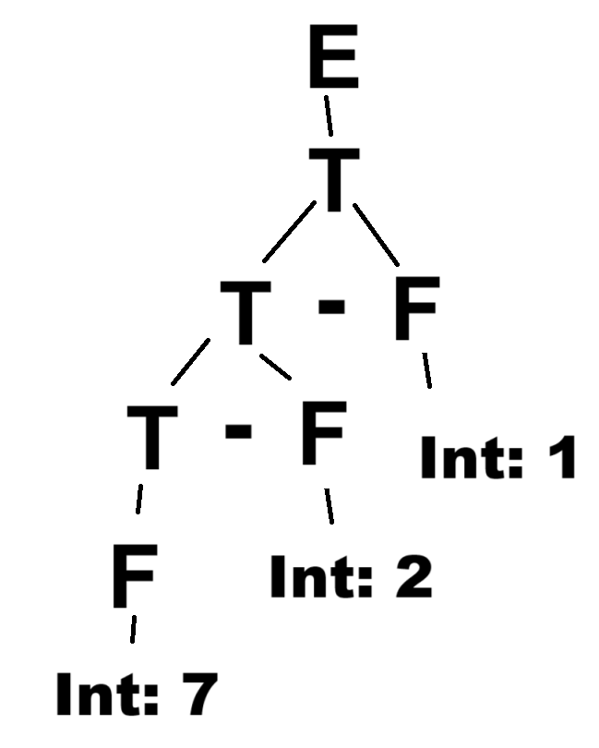  Result: 4 | Result: 4 | 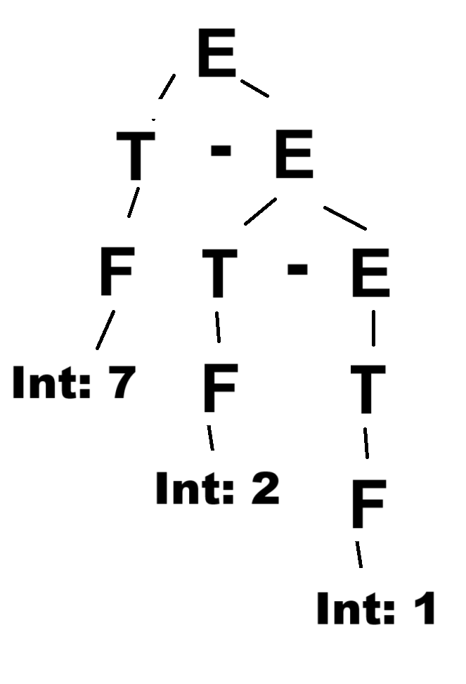  Result: 6 | Result: 4
7-(2-1) | 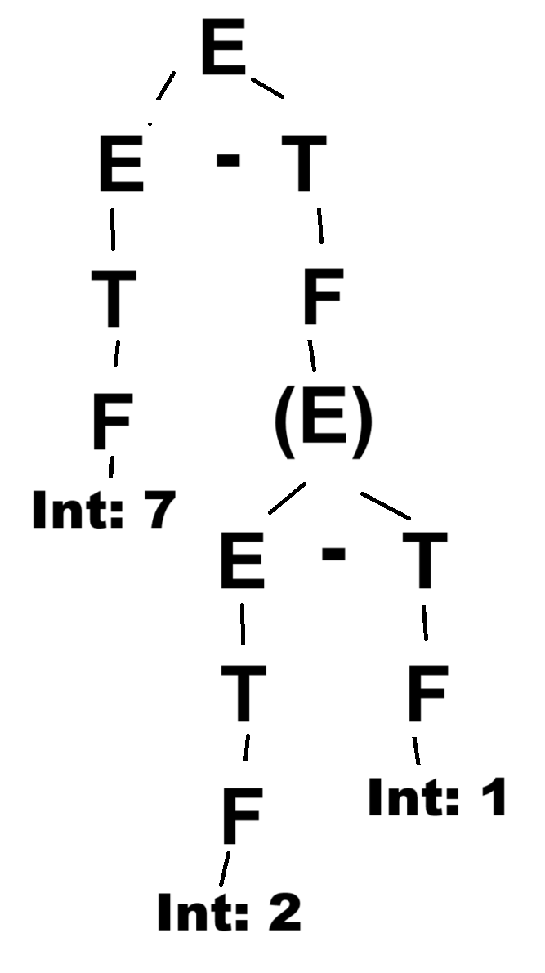  Result: 6 | 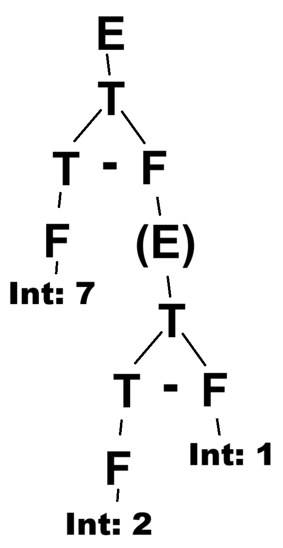  Result: 6 | Result: 6 | 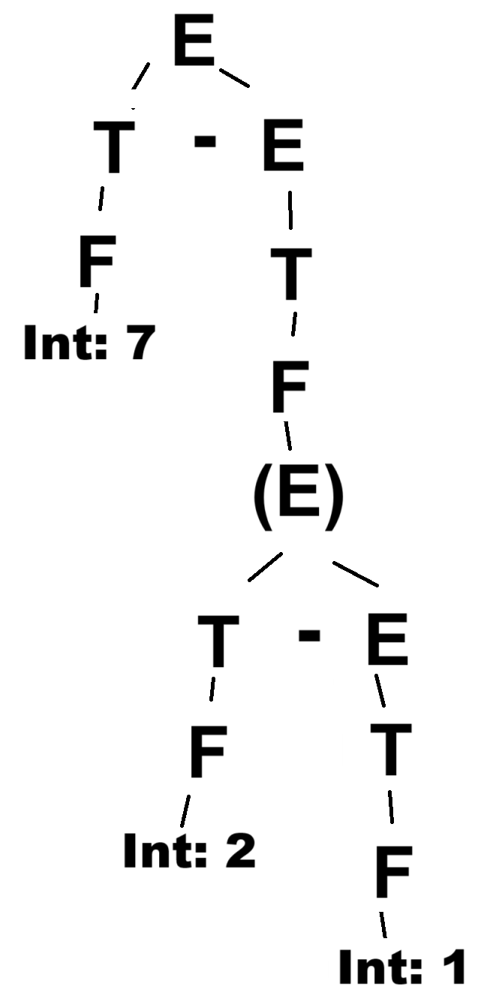  Result: 6 | Result: 6

4. Draw the parse tree and evaluate the results of the following expression with the given grammars.

2
-2
--2
3+2*-2
-3*2-4
-(3*2)-4

E → E+T | E – T | T
T→ T*F | T/F | F
F → (E) | Int

 | 2 | -2 | --2 = -(-2) | 3+2*-2 | -3*2-4 | -(3*2)-4
3-2 | 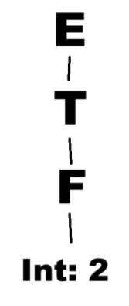  Result: 2 | 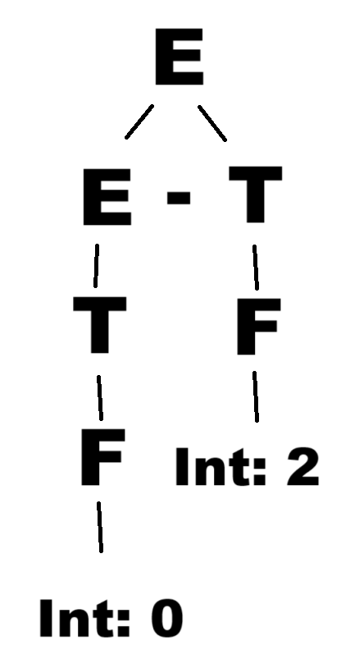  Result: -2 | 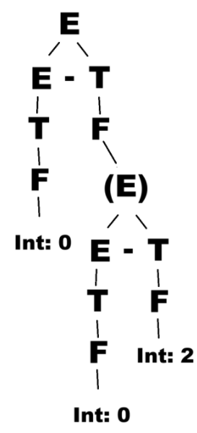  Result: 2 | 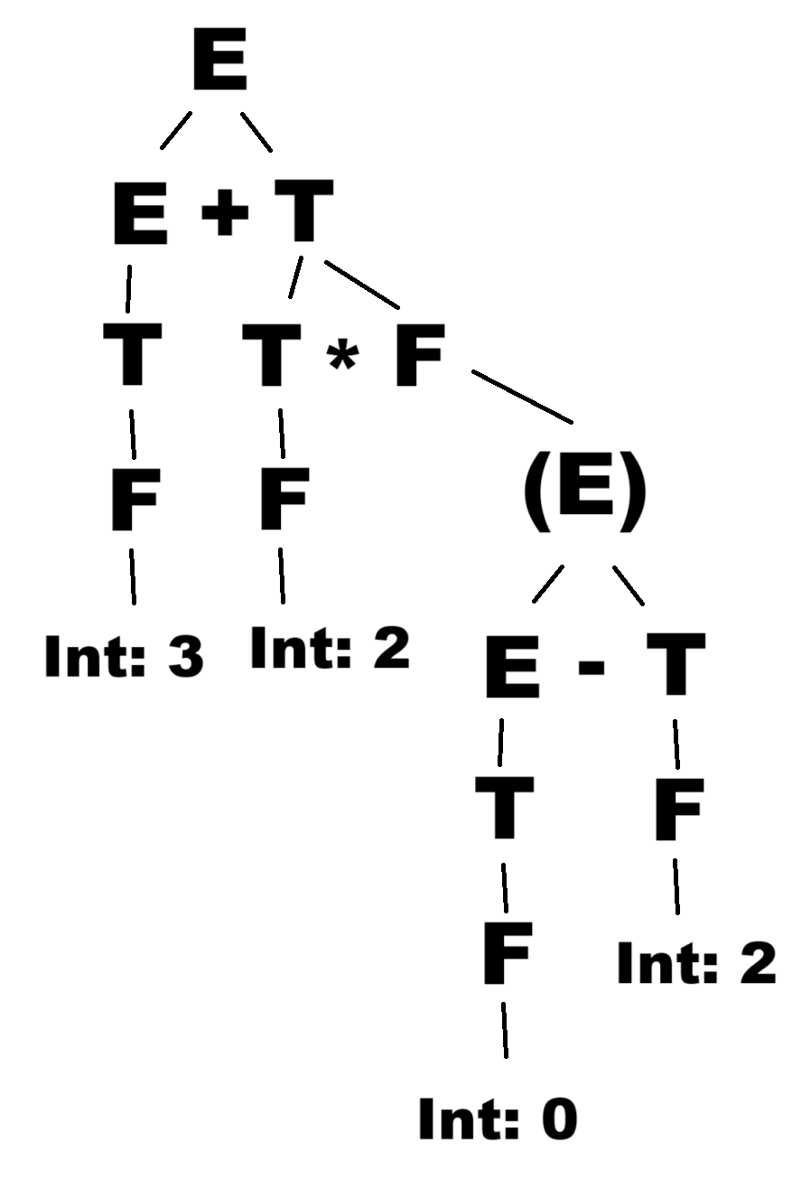  Result: -1 | 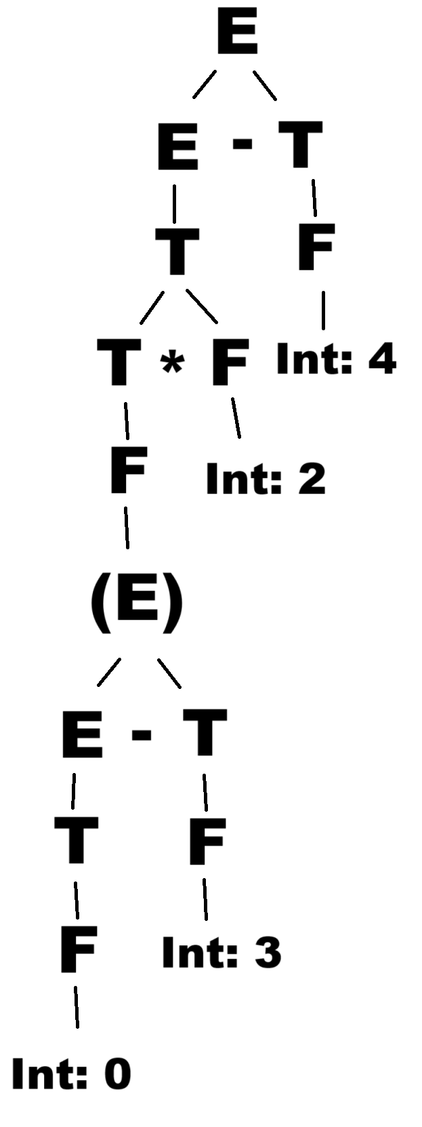  Result: -10 | 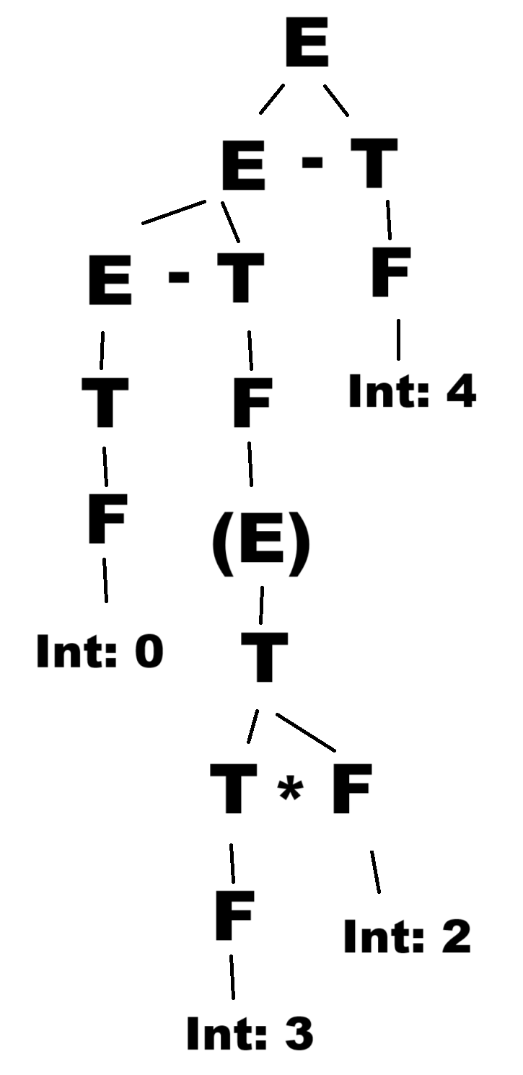  Result: -10

